Name: Nawal Fatima
Roll no: 94
Section: BSAI-3B
Lab task 4

Introduction:
Is lab mein hum ne informed search, yaani A* algorithm, ko campus routing graph par apply kiya. A* frontier ko f(n) = g(n) + h(n) se priority deta hai, jahan g ab tak ka asli cost hai aur h baqi cost ka estimate hai. Graph mein S start building hai aur G destination hai. Edges travel-time units hain, aur h ki values abstract time estimates hain (measured campus distance nahi).

Graph aur Heuristic
Node | Edges (cost) | h (supplied) | True remaining cost
S | A(1), B(4) | 5 | 6
A | C(2) | 4 | 5
B | G(5) | 4 | 5
C | G(3) | 2 | 3
G | - | 0 | 0
Do complete routes hain: S-A-C-G = 1 + 2 + 3 = 6 aur S-B-G = 4 + 5 = 9. Isliye optimal cost 6 hai.

Task 1: Pehli teen expansions (hand calculation)
Step | Selected | g, h, f | Calculation | Baqi frontier
1 | S | g=0, h=5, f=5 | f = 0 + 5 = 5 | A: g=1, h=4, f=1+4=5 | B: g=4, h=4, f=4+4=8
2 | A | g=1, h=4, f=5 | f = 1 + 4 = 5 | C: g=1+2=3, h=2, f=3+2=5 | B: f=8
3 | C | g=3, h=2, f=5 | f = 3 + 2 = 5 | G: g=3+3=6, h=0, f=6 | B: f=8
Next node kyun G? Frontier mein G ka f=6 hai aur B ka f=8, is liye sabse chhota f wala G select hota hai.
Step 1 ke baad A (f=5) ko B (f=8) par tarjeeh mili. Step 2 ke baad C (f=5) ko B (f=8) par tarjeeh mili. B ko A* ne kabhi expand nahi kiya.

Heuristic Audit
Admissibility: h kabhi asli remaining cost se zyada nahi honi chahiye.
Node | h | True cost | Check
S | 5 | 6 | 5 <= 6 OK
A | 4 | 5 | 4 <= 5 OK
B | 4 | 5 | 4 <= 5 OK
C | 2 | 3 | 2 <= 3 OK
G | 0 | 0 | 0 <= 0 OK

Consistency: har edge u -> v ke liye h(u) <= cost(u,v) + h(v).
Edge | Check | Result
S -> A | 5 <= 1 + 4 = 5 | OK
S -> B | 5 <= 4 + 4 = 8 | OK
A -> C | 4 <= 2 + 2 = 4 | OK
B -> G | 4 <= 5 + 0 = 5 | OK
C -> G | 2 <= 3 + 0 = 3 | OK
Is chhote instance par heuristic explicit verification se admissible aur consistent hai.

Task 2: A* aur UCS Comparison
Counting convention: node tab expanded count hota hai jab uske successors examine ho. Goal processing log hoti hai lekin count nahi hoti. Stale queue entries ignore ki gayin (is graph mein koi stale entry nahi aayi).
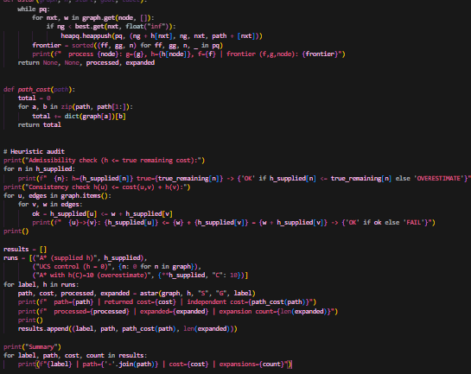

Output:
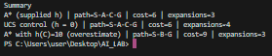

Run | Path | Cost | Expansions | Processed order
A* (supplied h) | S-A-C-G | 6 | 3 | S, A, C, G
UCS control (h = 0) | S-A-C-G | 6 | 4 | S, A, C, B, G
Independent cost check: 1 + 2 + 3 = 6 (dono runs ka path same hai). Dono ne optimal path diya, lekin A* ne 3 nodes expand kiye jabki UCS ne 4 (UCS ne B bhi expand kiya). Ye farq sirf is chhote graph par measured counts se nikla hai, general claim nahi.

Task 3: Overestimate Experiment
Sirf ek value badli: h(C) = 2 se 10. C ka asli remaining cost 3 hai, to 10 > 3 hai aur admissibility toot gayi. Baqi har cheez wahi rakhi (h(G) = 0, doosri h values, graph, start, goal).
Run | Path | Cost | Expansions | Processed order
A* original h | S-A-C-G | 6 | 3 | S, A, C, G
A* with h(C)=10 | S-B-G | 9 | 3 | S, A, B, G
Observed behavior: cost 6 se 9 ho gaya. A* ne A expand karne ke baad C ko f = 3 + 10 = 13 diya, jo B ke f = 8 se zyada tha, is liye B pehle expand hua aur G ko cost 9 par pahunch gaya.
Overestimate se optimality ki guarantee kyun toot'ti hai? Jab h asli cost se zyada ho to ek achhi continuation (C) ko ghalat tarah se mehnga dikha diya jata hai aur A* use examine hi nahi karta. Ye bhi dhyan rakho ke kuch overestimates par result badalta nahi, to sirf ek run mein result same aana heuristic ke safe hone ka saboot nahi.

Edge Case / Failure Analysis
Input: h(C) = 10, baqi sab original.
Observed behavior: A* ne non-optimal path S-B-G (cost 9) return kiya, jabki optimal cost 6 hai.
Likely cause: h(C) = 10 asli remaining cost 3 se bada hai, yaani heuristic inadmissible hai.
Proposed improvement: pehle admissibility aur consistency check karo (audit code ki tarah), aur h ko hamesha true remaining cost ke neeche rakho.

Limitations
Graph sirf 5 nodes ka hai aur heuristic values abstract hain, is liye efficiency ke natije sirf is instance par hain. Admissibility sirf is chhote graph par explicit check se saabit hui; bade graphs par alag proof chahiye hota hai.

Reflection
What did you learn today? A* asli cost aur estimate ko mila kar kam nodes expand karta hai, lekin ye tab hi optimal hai jab heuristic admissible ho.
How will you apply this? Navigation jaise problems mein straight-line type heuristic use karungi, magar pehle uski admissibility check karungi.
What failed or surprised you? Sirf ek heuristic value badalne se optimal path ghalat ho gaya.
What would you do differently? Zyada bare graph par A* aur UCS ke counts compare karungi.

Responsible Practice
Efficiency ke daave sirf measured expansion counts par based hain. Heuristic values synthetic aur abstract hain, aur ye baat report mein saaf likhi hai.

